|  |
| --- |
| Circle Language Spec: Commands |

## Active Command in Inactive Command

A clause in a clause only ever runs when its top parent command is an active command object. If the top parent command is an inactive command object, for instance a command definition, then even an *active* clause in it is dormant.

An executable command inside a command definition can not be run, because its parent is dormant, and an executable sub-command can not be referenced from elsewhere either.

### In a Diagram

A clause in a clause only ever runs when its top parent command is an active command object. If the top parent command is an inactive command object, for instance a command definition, then even an *active* clause in it is dormant.

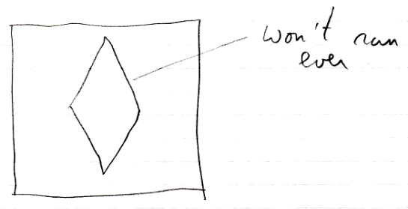

The clause will only ever run in a *call* to the definition, but then it is a copy of the definition’s clause:

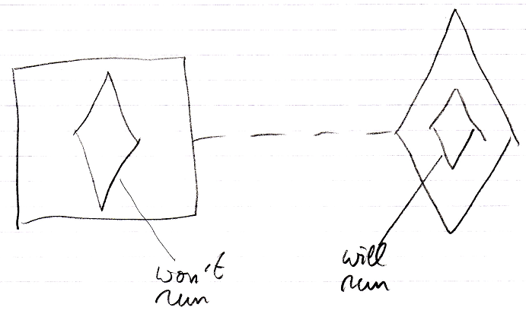

An executable command inside a command definition can not be run, because its parent is dormant, and an executable sub-command can not be referenced from elsewhere either.